1. Network devices: Functions and ports
Device | Main function | Typical ports
Switch | Connects computers, printers, and other devices in a LAN. | Ethernet ports, console port (for management), power port
Router | Connects different networks and directs data between them. | WAN port, LAN Ethernet ports, console port, power port
Hub | Sends incoming data to all connected ports. | Multiple Ethernet ports, power port
Firewall | Protects a network by filtering incoming and outgoing traffic. | WAN, LAN Ethernet ports, management port, power port
Access Point (AP) | Connects wireless devices to a wired network through Wi-Fi. | Ethernet port, power port, antennas (built-in or external)
Note: Port types vary by device model. Antennas are not ports; they transmit and receive wireless signals.
2. Network device diagrams and port labels
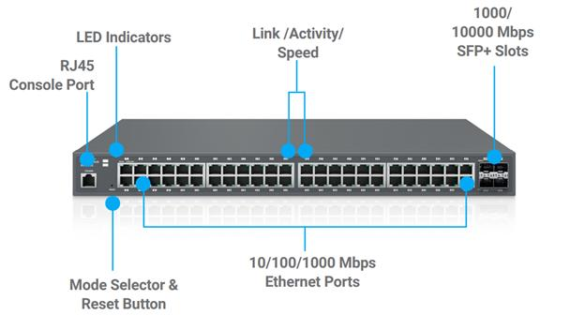
A. Switch
- Ethernet ports
- Console port
- Power connector
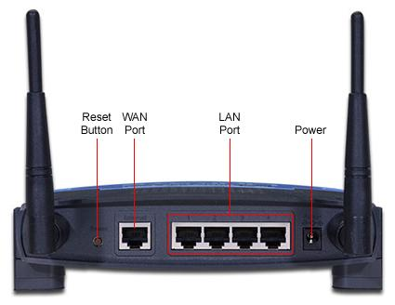
B. Router
- WAN port
- LAN ports
- Power connector
- Antennas
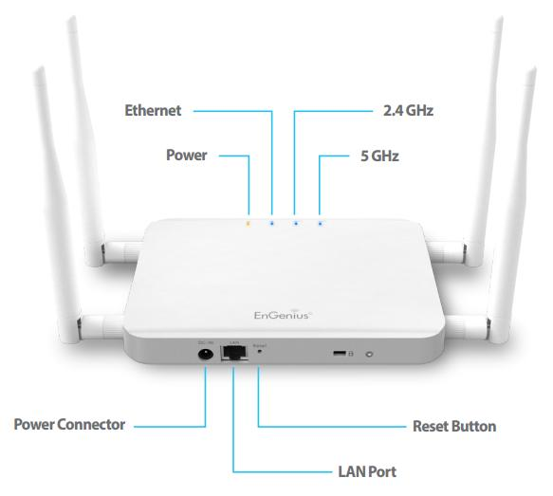
C. Access Point
- Ethernet port
- Power or PoE input
- Antennas
You can label these parts on the pictures or draw simple diagrams in your notebook.
3. How network devices help when using Instagram
- My phone connects to the home access point using Wi-Fi.
- The router forwards data between my home network and the internet.
- A switch, if present, connects wired devices and carries network traffic between them.
- A firewall filters traffic according to its security rules while I browse Instagram.
4. College Wi-Fi is slow or disconnects
Possible reason: The access points may be overloaded because too many students are connected, or the Wi-Fi coverage may be weak in some areas.
Suggested solution: Upgrade or add suitable access points with greater device capacity and better coverage. If the wired network is also congested, upgrading the switch or router may help handle traffic more efficiently.
Conclusion: Access points provide Wi-Fi coverage, switches connect devices within a LAN, and routers direct traffic between networks. The correct upgrade depends on where the bottleneck occurs.

